### The game

Definition

Sprouts is a [paper-and-pencil game](https://en.wikipedia.org/wiki/Paper-and-pencil_game) which can be analyzed for its [mathematical](https://en.wikipedia.org/wiki/Mathematics) properties. It was invented by [mathematicians](https://en.wikipedia.org/wiki/Mathematician) [John Horton Conway](https://en.wikipedia.org/wiki/John_Horton_Conway) and [Michael S. Paterson](https://en.wikipedia.org/wiki/Michael_S._Paterson) at [Cambridge University](https://en.wikipedia.org/wiki/University_of_Cambridge) in the early 1960s. Setup is even simpler than the popular [Dots and Boxes](https://en.wikipedia.org/wiki/Dots_and_Boxes) game, but game-play develops much more artistically and organically.

Rules

The game is played by two players,[[2]](https://en.wikipedia.org/wiki/Sprouts_(game)#cite_note-2) starting with a few spots drawn on a sheet of paper. Players take turns, where each turn consists of drawing a line between two spots (or from a spot to itself) and adding a new spot somewhere along the line. The players are constrained by the following rules.

* The line may be straight or curved, but must not touch or cross itself or any other line.
* The new spot cannot be placed on top of one of the endpoints of the new line. Thus the new spot splits the line into two shorter lines.
* No spot may have more than three lines attached to it. For the purposes of this rule, a line from the spot to itself counts as two attached lines and new spots are counted as having two lines already attached to them

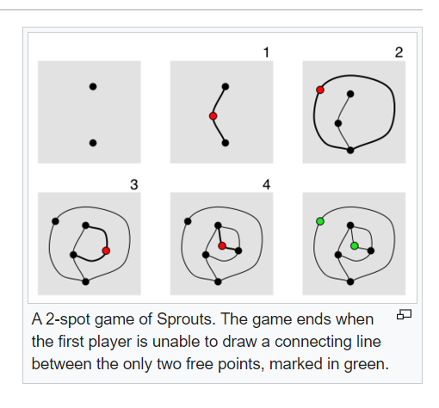

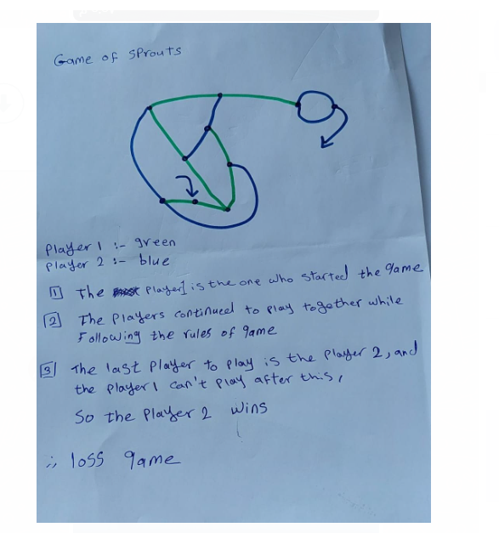

2Do not apply this theory because the game does not have a tie result

## Conclusions of Zermelo's theorem

Zermelo's work shows that in two-person [zero-sum](https://en.wikipedia.org/wiki/Zero-sum_game) games with perfect information,

if a player is in a winning position, then that player can always force a win no matter what strategy the other player may employ.

Furthermore, and as a consequence, if a player is in a winning position, it will never require more moves than there are positions in the game (with a position defined as position of pieces as well as the player next to move).[[1]](https://en.wikipedia.org/wiki/Zermelo%27s_theorem_(game_theory)#cite_note-Schwalbe-1)

3

Yes, it has a winning strategy but doesn’t have a tie strategy

## Winning strategies

Since Sprouts is a finite game where no draw is possible, a perfect strategy exists either for the first or the second player, depending on the number of initial spots. The main question about a given starting position is then to determine which player can force a win if they play perfectly.

When the winning strategy is for the first player, it is said that the *outcome* of the position is a "win", and when the winning strategy is for the second player, it is said that the outcome of the position is a "loss" (because it is a loss from the point of view of the first player).

The outcome is determined by developing the [game tree](https://en.wikipedia.org/wiki/Game_tree) of the starting position. This can be done by hand only for a small number of spots, and all the new results since 1990 have been obtained by extensive search with computers.

## 4

## strategy winning of game of sprouts

## The correct approach is to consider the number of lives (opportunities to connect a line) instead of the number of spots. Then, it can be shown that if the game starts with n spots, it will end in no more than 3n−1 moves and no fewer than 2n moves

## In this game, there is an advantage to going first .

## In fact, if we start with an odd number of free spots (3, 5, or 7) the first player will win most often.

## Ironically, if we start with an even number of free spots (such as 4, or 6) the first player can still win! But a great deal depends on the moves made by your opponent.

## To best familiarize yourself with the game, begin with three with three free spots, then gradually increase the number of three spots until you reach seven.

<https://en.wikipedia.org/wiki/File:Sprouts-2spot-game.png>

<https://en.wikipedia.org/wiki/Zermelo%27s_theorem_(game_theory)>